AI Projects: Behavioural Neuroscience Laboratory, EMV, Lund University
(www.behavioural-neuroscience.com)

Project(s): Quantification of functional deficits in preclinical rodent models of neurodegenerative diseases using AI.

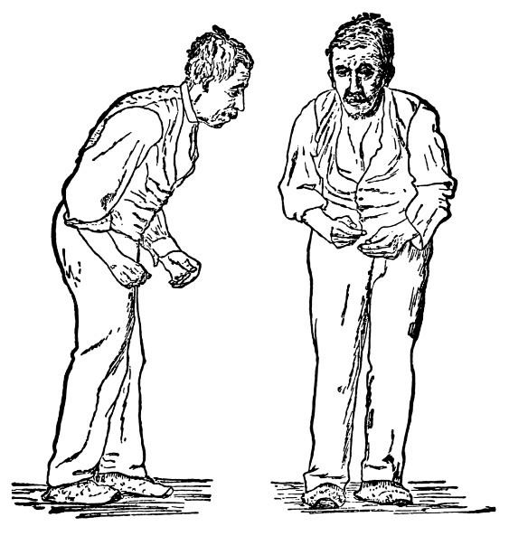
Background:

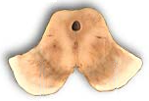
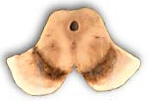
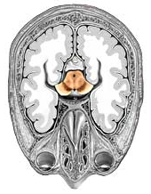

Parkinson’s disease is a neurodegenerative disorder which is characterised by Tremor, muscle rigidity, impairments in movement initiation, posture and balance.
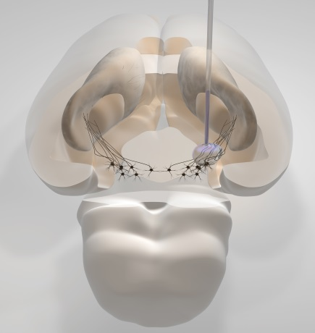
The core pathology is caused by a loss of cells in the brain which produce the neurotransmitter dopamine.
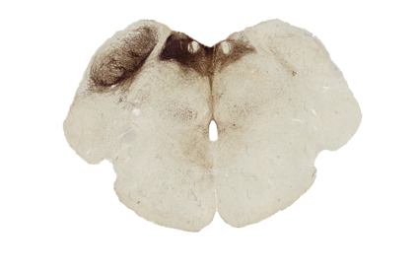

We model Parkinson’s disease in rats by injecting a toxin into the brain that is selectively killing off the dopamine cells.

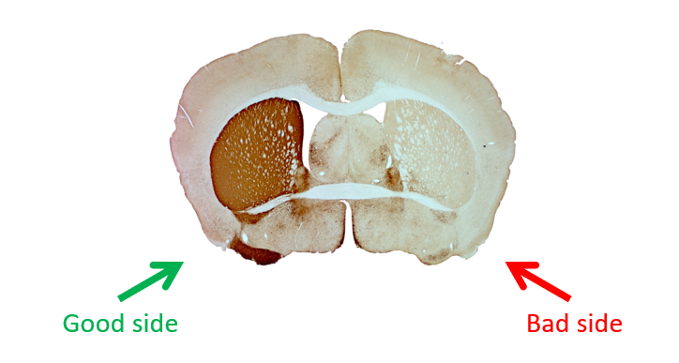
The brain has two hemispheres and each hemisphere is controlling one side of the body. Because there is a loss of dopamine in one side of the brain whilst the other side is still intact, this leads to lateralised behavioural impairments on behavioural tasks. For example, the rat will use one paw preferentially when reaching for food.

In our lab we use many behavioural tests to quantify behaviour in order to assess the effects of therapeutic interventions such as pharmacological drugs, gene-therapy or stem cell transplants. The behavioural testing is very laborious and time consuming. Here is where AI could offer a solution to automatize the behavioural assessments.
There are several packages that have been published that have pre-trained networks to track the animals behaviour, most famously deeplabcut:
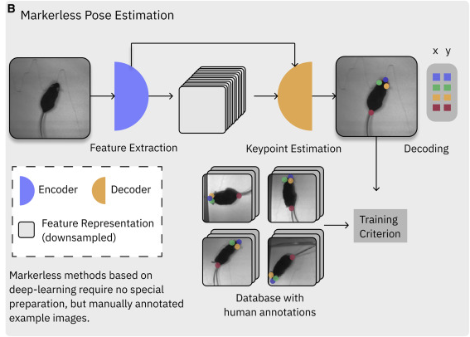

Project:
In the proposed project the group will use DLC to quantify behaviour on behavioural tests relevant for our research:
1.) Corridor test:
How many sugar pellets does the rat eat from the left/right side?
(the sugar pellets are in the little cups and rats without dopamine will ignore one side)
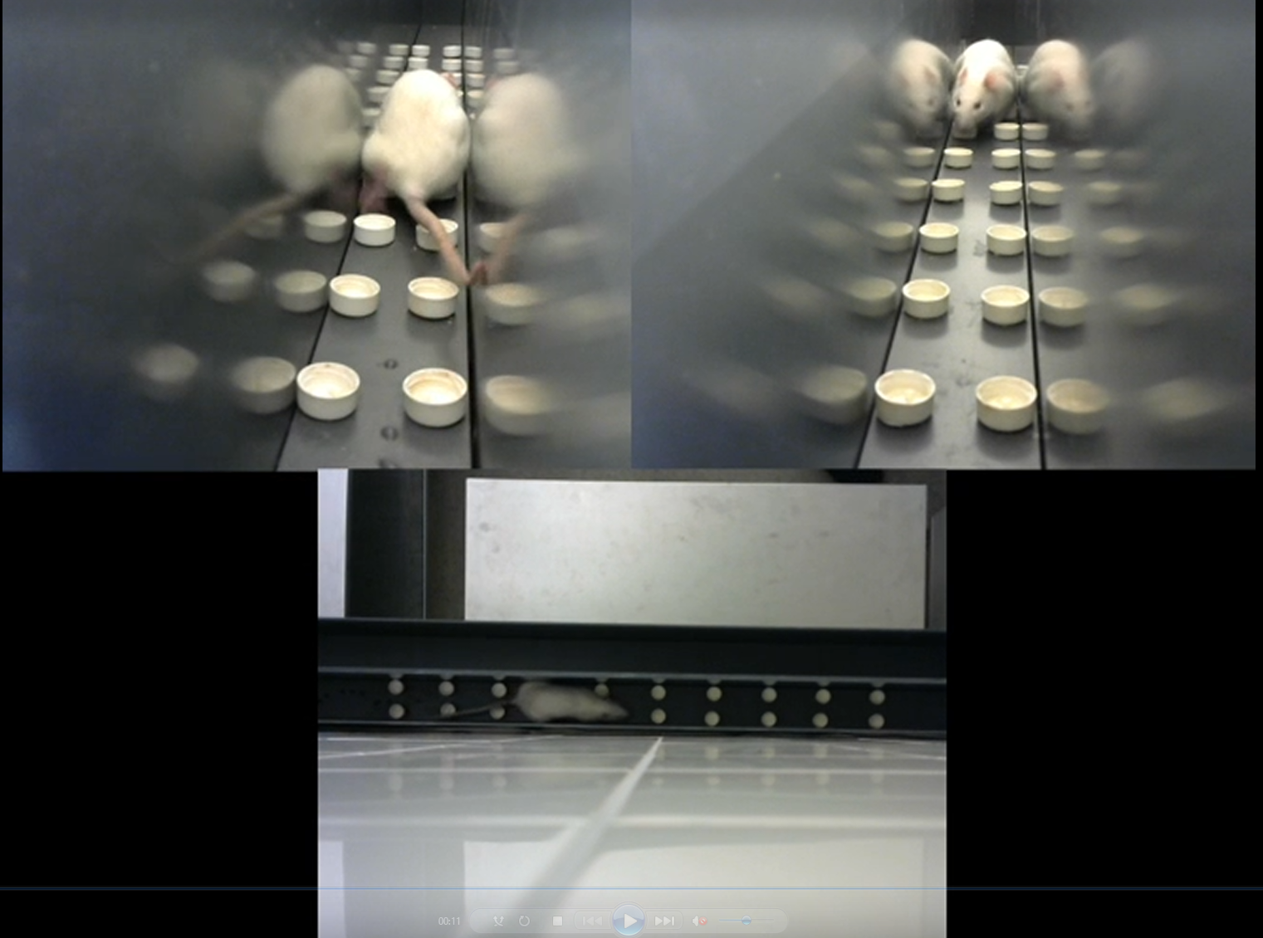
2.) Cylinder test:
How many touches does the rat make with the left/right paw respectively to the cylinder wall?
(rats without dopamine will not use one paw very much)
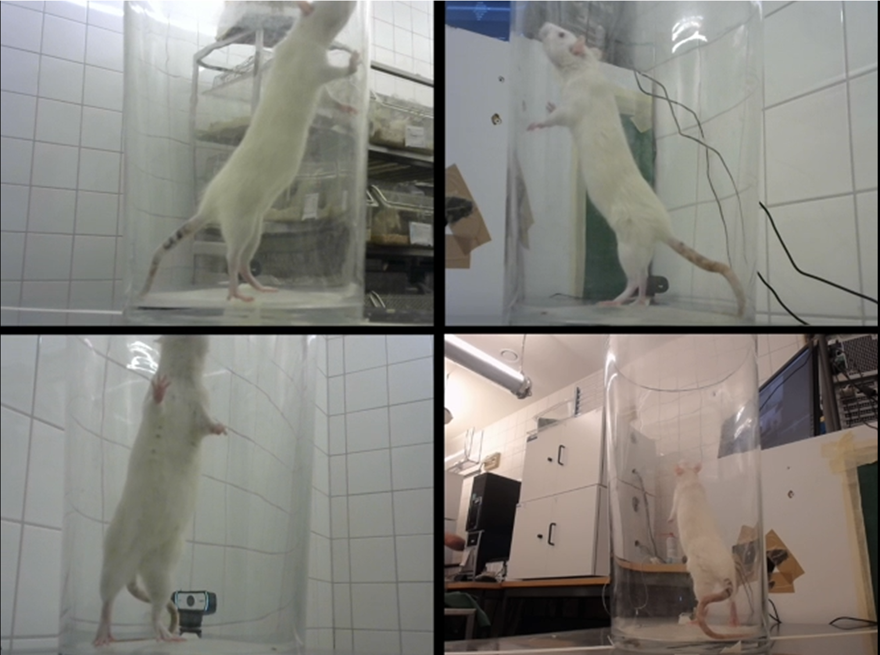
3.) Gait analysis:
Is walking affected (stride length, base width, etc) in “Parkinson” rats?
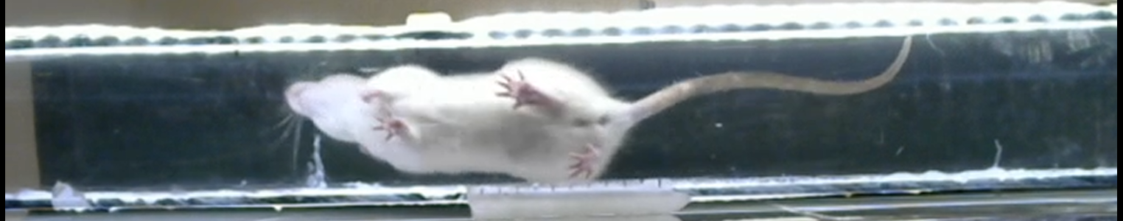
We have recorded all videos and after training the project will be used to assess normal rats, rats with “parkinsons” and rats that have received a stem cell transplant.

If interested contact:
Andreas Heuer,
andreas.heuer@med.lu.se

