Bomberman, Videogame
  - Project in Embedded Systems Design, Advanced Course

Introduction
Bomberman is a classic game that became famous in the mid-80s as the true birth of multiplayer gaming after its release on the Nintendo Entertainment System. It involves two players that drop bombs in order to blast a way to the other play to ultimately outsmart the other player and destroy them.

Gameplay
The game consists of a 13x11 grid. The two players start in opposite corners of the game grid. Controlling the characters is done through the keyboard (arrows/WASD for moving and 1/L for dropping bombs, space starts game and pauses). The placements of destroyable blocks are random but the non-destroyable blocks are pre-placed (see figure 1).
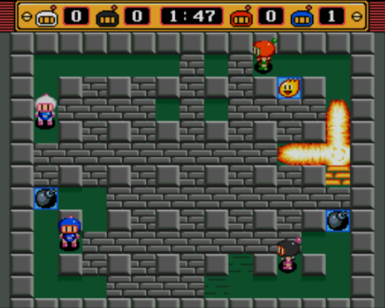
Figure 1. Bomberman game board on the Super NES. ©Nintendo™ Corp.

Implementation
The game logic is going to be developed in software running on the microblaze processor. The VGA controller (Graphics Accelerator) as well as the keyboard interface and the possible audio controller are done in hardware (see figure 2).
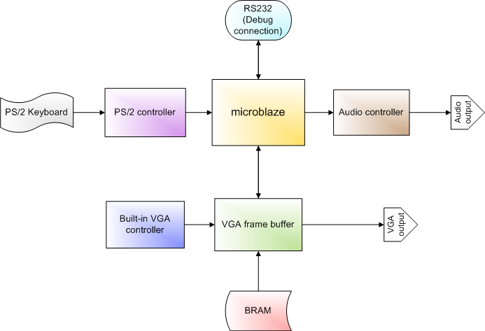
Figure 2. Connection scheme of the Bomberman-project

VGA output
The VGA output will be 640x480 pixels @ 60 Hz. The software sends game board (13x11) to a hardware component that acts as a frame buffer and receives the Hcount & Vcount from the built-in VGA controller (see figure 3). The component decodes the correct pixel color from a picture stored in memory (BRAM if possible) and sends it to the VGA output.
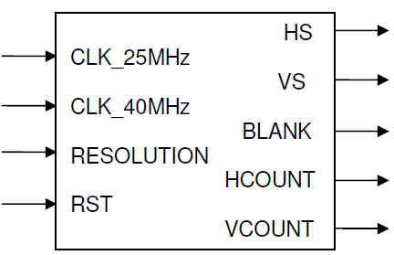
Figure 3. Built in VGA controller.

Keyboard controller
The keyboard is to be connected by interfacing the existing PS/2 unit to be able to receive keystrokes to our game.

(Audio controller)
If there are time and available units, an audio controller is to be attached to the system to using the PMOD interface. The Sounds would consist of simple explosion sounds for the bombs to increase the game immersion factor.

Time plan
Week 1 (5-9 sept) | Project Proposal | All
Week 2 | Software/keyboard interaction | Michael
Week 2 | VGA interface /w Graphics Acc. | Linus / Mikael
Week 3 | Connecting CPU – Graphics Acc. | Michael / Mikael / Linus
Week 4 | Game Logics – User input | Michael
Week 4 – 5 | Game Logics – Board Update | Mikael
Week 4 – 5 | Graphics Accelerator | Linus
Week 5 | Game graphics | All
Week 6 | Final Testing and Report | All (respective parts)

